TC_03_Validate CMM xml for V3.1.6 at CustomerPreferences/OptChoice and CustomerSubscriptions

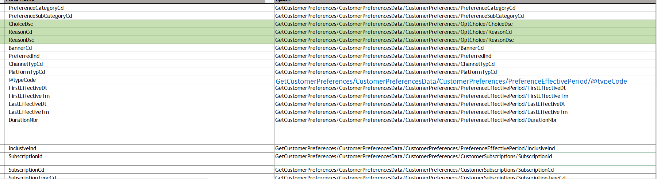

Sample JSON-

{"_id":"CustomerPreferences_7fd1be37-4965-4357-813e-e7566e919408","_class":"PreferenceAggregateStateDomain_v1","aggregateId":"7fd1be37-4965-4357-813e-e7566e919408","aggregateType":"CustomerPreferences","state":{"_class":"PreferenceAggregateDomain_v1","createTimestamp":{"$numberLong":"1556743804336"},"lastUpdateTimestamp":{"$numberLong":"1557180929106"},"createClientId":"EDSS","lastUpdateClientId":"EDSS","createHostName":"c8958ff9-b090-4362-404b-8ace","lastUpdateHostName":"c8958ff9-b090-4362-404b-8ace","aggregateId":"7fd1be37-4965-4357-813e-e7566e919408","aggregateType":"CustomerPreferences","sequenceNumber":5,"timestamp":{"$numberLong":"1557180927305"},"aggregateRevision":5,"version":1,"eventId":"6526b1da-f127-45ad-a43b-8ae67cd0920a","guid":"230-239-1549578339622","preferences":[{"_class":"DeliverySubscriptionPreferenceAggregateDomain_v1","preferenceId":1,"value":"f9b88f7e-5f54-4536-afc0-8b080d189cdf","type":"MONTHLYPLAN","categoryCode":"DELIVERY","subCategoryCode":"SUBSCRIPTION","channel":{"type":"Channel-Type"},"platform":{"type":"Platform-Type"},"optChoices":[{"_class":"OptChoiceAggregateDomain_v1","choice":"PENDING_CANCELLATION","reasonCode":"CHANGE_PLAN"},{"_class":"OptChoiceAggregateDomain_v1","choice":"CANCELLED","reasonCode":"-1","reasonText":"declined"}],"effectiveTimePeriods":[{"_class":"EffectiveTimePeriodAggregateDomain_v1","type":"ACTIVE","inclusiveInd":1,"startDate":"2019-05-03","startTime":"06:00","duration":"31D","endDate":"2019-06-02","endTime":"00:00"},{"_class":"EffectiveTimePeriodAggregateDomain_v1","type":"CANCELLED","inclusiveInd":1,"startDate":"2019-06-03","startTime":"06:00","duration":"3W","endDate":"2019-06-04","endTime":"11:00"}],"deliverySubscriptionOffer":{"_class":"DeliverySubcriptionOfferAggregateDomain_v1","serviceFeeWaived":1,"deliveryFeeWaived":1,"fuelSurchargeWaived":1,"minBasketSize":30,"fee":{"_class":"CurrencyDomain_v1","currency":"USD","amount":14.95},"initialOrderAmountOff":{"_class":"CurrencyDomain_v1","currency":"USD","amount":20},"signUpFee":{"_class":"CurrencyDomain_v1","currency":"USD","amount":14.95}},"autoEnroll":1,"autoRenew":1},{"_class":"DeliverySubscriptionPreferenceAggregateDomain_v1","preferenceId":2,"value":"f9b88f7e-5f54-4536-afc0-8b080d189cdf","type":"MONTHLYPLAN","categoryCode":"DELIVERY","subCategoryCode":"SUBSCRIPTION","optChoices":[{"_class":"OptChoiceAggregateDomain_v1","choice":"PENDING_ACTIVATION","reasonCode":"CHANGE_PLAN"}],"effectiveTimePeriods":[{"_class":"EffectiveTimePeriodAggregateDomain_v1","type":"PENDING_ACTIVATION","inclusiveInd":1,"startDate":"2019-06-03","startTime":"00:00","duration":"30D","endDate":"2019-07-02","endTime":"00:00"}],"deliverySubscriptionOffer":{"_class":"DeliverySubcriptionOfferAggregateDomain_v1","serviceFeeWaived":1,"deliveryFeeWaived":1,"fuelSurchargeWaived":1,"minBasketSize":30,"fee":{"_class":"CurrencyDomain_v1","currency":"USD","amount":14.95},"initialOrderAmountOff":{"_class":"CurrencyDomain_v1","currency":"USD","amount":20}},"autoEnroll":1,"autoRenew":1}]}}

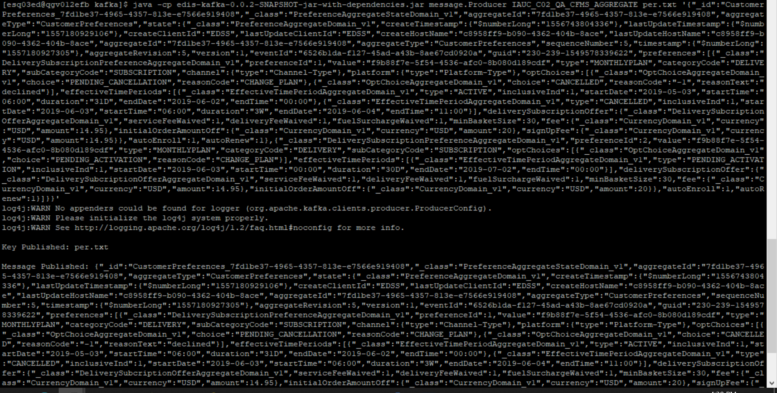

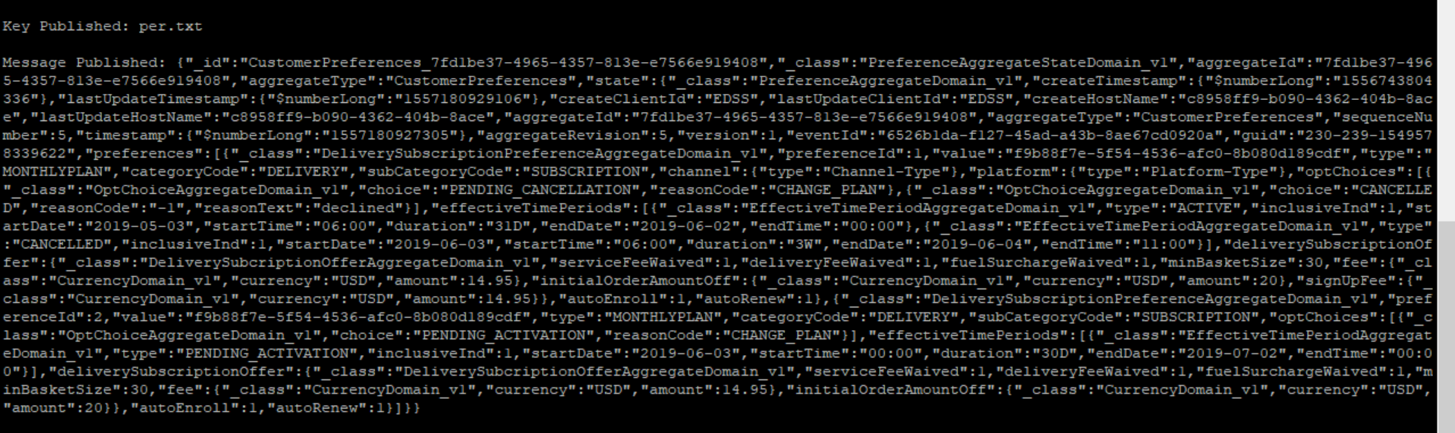

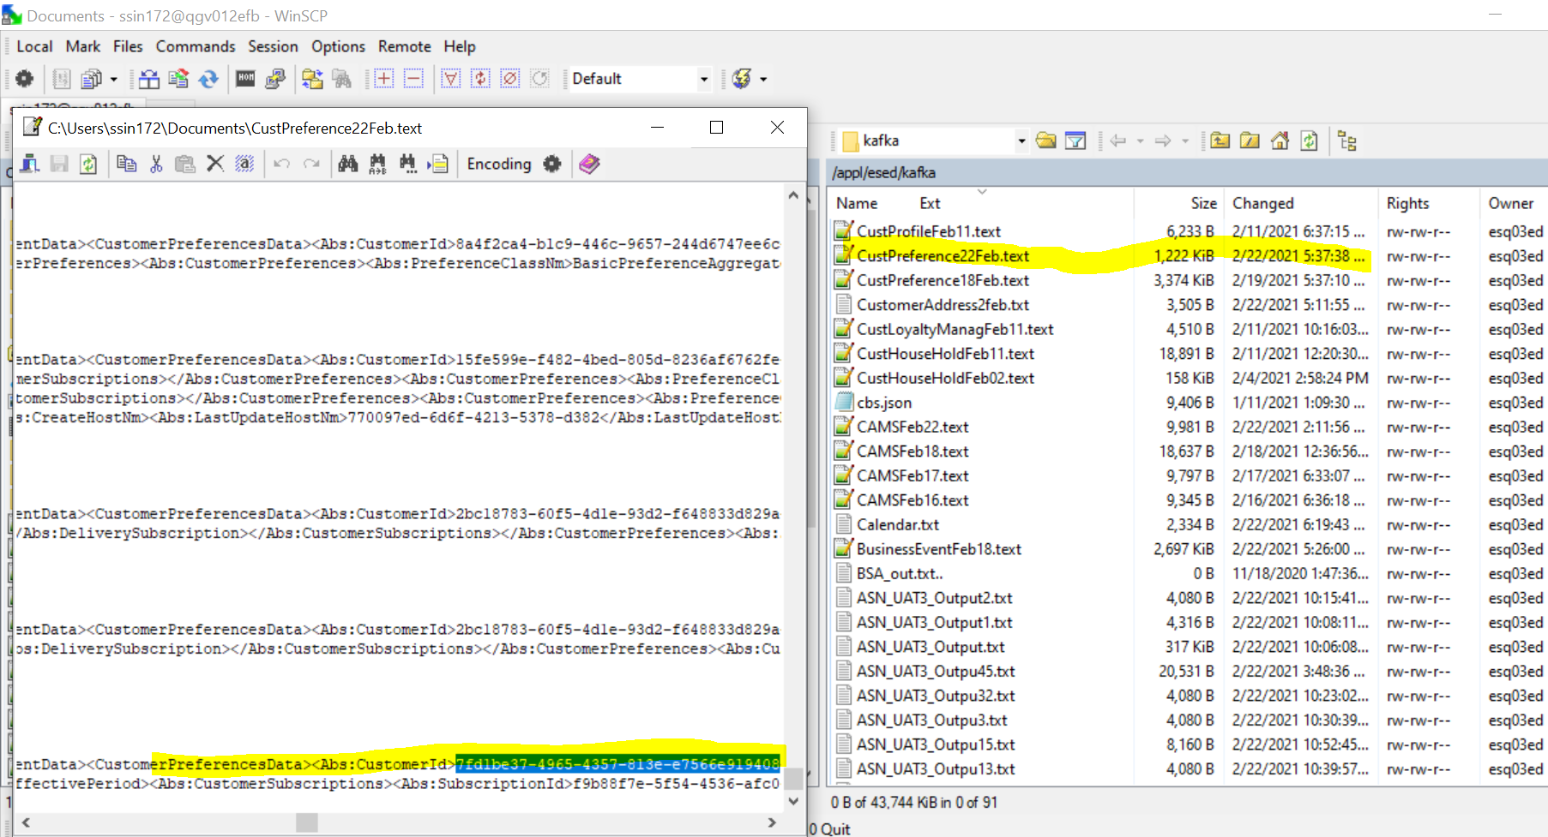

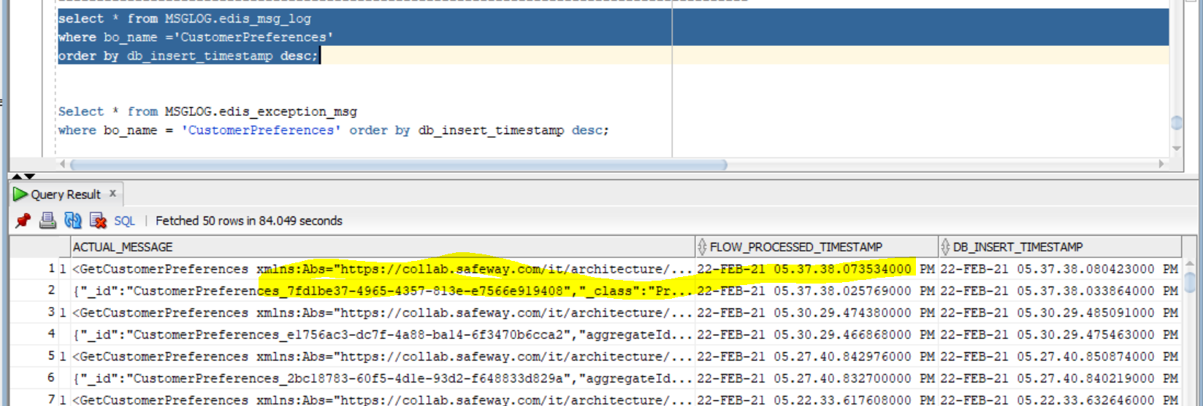

CMM xml-

<GetCustomerPreferences

xmlns:Abs="https://collab.safeway.com/it/architecture/info/default.aspx">

<DocumentData>

<Document VersionId="3.1.5.033" SystemEnvironmentCd="QA">

<Abs:DocumentID>IAUC_C02_QA_CFMS_AGGREGATE</Abs:DocumentID>

<Abs:AlternateDocumentID>IAUC_C02_QA_CFMS_AGGREGATE_1_1102_20210222173738028581</Abs:AlternateDocumentID>

<Abs:InboundOutboundInd>Outbound from Albertsons</Abs:InboundOutboundInd>

<Abs:DocumentNm>GetCustomerPreference</Abs:DocumentNm>

<Abs:CreationDt>2021-02-22T17:37:38.028581</Abs:CreationDt>

<Abs:Description>Retail customer&apos;s generic preferences and the subscriptions</Abs:Description>

<Abs:SourceApplicationCd>CFMS</Abs:SourceApplicationCd>

<Abs:TargetApplicationCd>EDIS</Abs:TargetApplicationCd>

<Abs:InternalFileTransferInd>Y</Abs:InternalFileTransferInd>

<Abs:DataClassification>

<Abs:DataClassificationLevel>

<Abs:Code>Internal</Abs:Code>

</Abs:DataClassificationLevel>

<Abs:BusinessSensitivityLevel>

<Abs:Code>Low</Abs:Code>

</Abs:BusinessSensitivityLevel>

<Abs:PHIdataInd>N</Abs:PHIdataInd>

<Abs:PCIdataInd>N</Abs:PCIdataInd>

<Abs:PIIdataInd>N</Abs:PIIdataInd>

</Abs:DataClassification>

</Document>

<DocumentAction>

<Abs:ActionTypeCd>UPDATE</Abs:ActionTypeCd>

<Abs:RecordTypeCd>CHANGE</Abs:RecordTypeCd>

</DocumentAction>

</DocumentData>

<CustomerPreferencesData>

<Abs:CustomerId>7fd1be37-4965-4357-813e-e7566e919408</Abs:CustomerId>

<Abs:CustomerPreferences>

<Abs:PreferenceClassNm>DeliverySubscriptionPreferenceAggregateDomain_v1</Abs:PreferenceClassNm>

<Abs:PreferenceCd>1</Abs:PreferenceCd>

<Abs:PreferenceTypeCd>MONTHLYPLAN</Abs:PreferenceTypeCd>

<Abs:PreferenceVal>f9b88f7e-5f54-4536-afc0-8b080d189cdf</Abs:PreferenceVal>

<Abs:PreferenceCategoryCd>DELIVERY</Abs:PreferenceCategoryCd>

<Abs:PreferenceSubCategoryCd>SUBSCRIPTION</Abs:PreferenceSubCategoryCd>

<Abs:OptChoice>

<Abs:ChoiceDsc>PENDING_CANCELLATION</Abs:ChoiceDsc>

<Abs:ReasonCd>CHANGE_PLAN</Abs:ReasonCd>

</Abs:OptChoice>

<Abs:OptChoice>

<Abs:ChoiceDsc>CANCELLED</Abs:ChoiceDsc>

<Abs:ReasonCd>-1</Abs:ReasonCd>

<Abs:ReasonDsc>declined</Abs:ReasonDsc>

</Abs:OptChoice>

<Abs:ChannelTypCd>Channel-Type</Abs:ChannelTypCd>

<Abs:PlatformTypCd>Platform-Type</Abs:PlatformTypCd>

<Abs:PreferenceEffectivePeriod Abs:typeCode="ACTIVE">

<Abs:FirstEffectiveDt>2019-05-03</Abs:FirstEffectiveDt>

<Abs:FirstEffectiveTm>06:00:00.000</Abs:FirstEffectiveTm>

<Abs:LastEffectiveDt>2019-06-02</Abs:LastEffectiveDt>

<Abs:LastEffectiveTm>00:00:00.000</Abs:LastEffectiveTm>

<Abs:DurationNbr>31</Abs:DurationNbr>

<Abs:DurationUnitDsc>Days</Abs:DurationUnitDsc>

<Abs:InclusiveInd>1</Abs:InclusiveInd>

</Abs:PreferenceEffectivePeriod>

<Abs:PreferenceEffectivePeriod Abs:typeCode="CANCELLED">

<Abs:FirstEffectiveDt>2019-06-03</Abs:FirstEffectiveDt>

<Abs:FirstEffectiveTm>06:00:00.000</Abs:FirstEffectiveTm>

<Abs:LastEffectiveDt>2019-06-04</Abs:LastEffectiveDt>

<Abs:LastEffectiveTm>11:00:00.000</Abs:LastEffectiveTm>

<Abs:DurationNbr>3</Abs:DurationNbr>

<Abs:DurationUnitDsc>Weeks</Abs:DurationUnitDsc>

<Abs:InclusiveInd>1</Abs:InclusiveInd>

</Abs:PreferenceEffectivePeriod>

<Abs:CustomerSubscriptions>

<Abs:SubscriptionId>f9b88f7e-5f54-4536-afc0-8b080d189cdf</Abs:SubscriptionId>

<Abs:SubscriptionCd>SUBSCRIPTION</Abs:SubscriptionCd>

<Abs:SubscriptionTypeCd>MONTHLYPLAN</Abs:SubscriptionTypeCd>

<Abs:DeliverySubscription>

<Abs:Fee CurrencyCd="USD" FeeAmt="14.95"/>

<Abs:ServiceFeeWaivedInd>1</Abs:ServiceFeeWaivedInd>

<Abs:DeliveryFeeWaivedInd>1</Abs:DeliveryFeeWaivedInd>

<Abs:FuelSurchargeWaivedInd>1</Abs:FuelSurchargeWaivedInd>

<Abs:MinimumBasketSizeQty>30</Abs:MinimumBasketSizeQty>

<Abs:AutoRenewInd>1</Abs:AutoRenewInd>

<Abs:AutoEnrollInd>1</Abs:AutoEnrollInd>

<Abs:InitialOrderAmountOff CurrencyCd="USD" DiscountAmt="20.00"/>

<Abs:SignupFee CurrencyCd="USD" FeeAmt="14.95"/>

</Abs:DeliverySubscription>

</Abs:CustomerSubscriptions>

</Abs:CustomerPreferences>

<Abs:CustomerPreferences>

<Abs:PreferenceClassNm>DeliverySubscriptionPreferenceAggregateDomain_v1</Abs:PreferenceClassNm>

<Abs:PreferenceCd>2</Abs:PreferenceCd>

<Abs:PreferenceTypeCd>MONTHLYPLAN</Abs:PreferenceTypeCd>

<Abs:PreferenceVal>f9b88f7e-5f54-4536-afc0-8b080d189cdf</Abs:PreferenceVal>

<Abs:PreferenceCategoryCd>DELIVERY</Abs:PreferenceCategoryCd>

<Abs:PreferenceSubCategoryCd>SUBSCRIPTION</Abs:PreferenceSubCategoryCd>

<Abs:OptChoice>

<Abs:ChoiceDsc>PENDING_ACTIVATION</Abs:ChoiceDsc>

<Abs:ReasonCd>CHANGE_PLAN</Abs:ReasonCd>

</Abs:OptChoice>

<Abs:PreferenceEffectivePeriod Abs:typeCode="PENDING_ACTIVATION">

<Abs:FirstEffectiveDt>2019-06-03</Abs:FirstEffectiveDt>

<Abs:FirstEffectiveTm>00:00:00.000</Abs:FirstEffectiveTm>

<Abs:LastEffectiveDt>2019-07-02</Abs:LastEffectiveDt>

<Abs:LastEffectiveTm>00:00:00.000</Abs:LastEffectiveTm>

<Abs:DurationNbr>30</Abs:DurationNbr>

<Abs:DurationUnitDsc>Days</Abs:DurationUnitDsc>

<Abs:InclusiveInd>1</Abs:InclusiveInd>

</Abs:PreferenceEffectivePeriod>

<Abs:CustomerSubscriptions>

<Abs:SubscriptionId>f9b88f7e-5f54-4536-afc0-8b080d189cdf</Abs:SubscriptionId>

<Abs:SubscriptionCd>SUBSCRIPTION</Abs:SubscriptionCd>

<Abs:SubscriptionTypeCd>MONTHLYPLAN</Abs:SubscriptionTypeCd>

<Abs:DeliverySubscription>

<Abs:Fee CurrencyCd="USD" FeeAmt="14.95"/>

<Abs:ServiceFeeWaivedInd>1</Abs:ServiceFeeWaivedInd>

<Abs:DeliveryFeeWaivedInd>1</Abs:DeliveryFeeWaivedInd>

<Abs:FuelSurchargeWaivedInd>1</Abs:FuelSurchargeWaivedInd>

<Abs:MinimumBasketSizeQty>30</Abs:MinimumBasketSizeQty>

<Abs:AutoRenewInd>1</Abs:AutoRenewInd>

<Abs:AutoEnrollInd>1</Abs:AutoEnrollInd>

<Abs:InitialOrderAmountOff CurrencyCd="USD" DiscountAmt="20.00"/>

<Abs:SignupFee/>

</Abs:DeliverySubscription>

</Abs:CustomerSubscriptions>

</Abs:CustomerPreferences>

<Abs:SourceAuditData>

<Abs:SourceNm>CustomerPreferences</Abs:SourceNm>

<Abs:CreateTs>2019-05-01T20:50:04.336Z</Abs:CreateTs>

<Abs:LastUpdateTs>2019-05-06T22:15:29.106Z</Abs:LastUpdateTs>

<Abs:CreateClientId>EDSS</Abs:CreateClientId>

<Abs:LastUpdateClientId>EDSS</Abs:LastUpdateClientId>

<Abs:CreateHostNm>c8958ff9-b090-4362-404b-8ace</Abs:CreateHostNm>

<Abs:LastUpdateHostNm>c8958ff9-b090-4362-404b-8ace</Abs:LastUpdateHostNm>

<Abs:SequenceNbr>5</Abs:SequenceNbr>

<Abs:AggregateTs>2019-05-06T22:15:27.305Z</Abs:AggregateTs>

<Abs:AggregateRevisionNbr>5</Abs:AggregateRevisionNbr>

<Abs:PayloadVersionNbr>1</Abs:PayloadVersionNbr>

<Abs:EventId>6526b1da-f127-45ad-a43b-8ae67cd0920a</Abs:EventId>

</Abs:SourceAuditData>

</CustomerPreferencesData>

</GetCustomerPreferences>

Scenario – 2 validate Version 3.1.6 in CMM xml

{"_id":"CustomerPreferences_c725c4b0-8e62-41ca-8d9b-a5b5bec29027","_class":"PreferenceAggregateStateDomain_v1","aggregateId":"c725c4b0-8e62-41ca-8d9b-a5b5bec29027","aggregateType":"CustomerPreferences","state":{"_class":"PreferenceAggregateDomain_v1","createTimestamp":{"$numberLong":"1558040827206"},"createUserId":"100-090-1558040722386","lastUpdateTimestamp":{"$numberLong":"1558041612907"},"lastUpdateUserId":"100-090-1558040722386","createClientId":"EDSS","lastUpdateClientId":"EDSS","createHostName":"81ba4e78-3b19-4feb-515f-7e2a","lastUpdateHostName":"81ba4e78-3b19-4feb-515f-7e2a","aggregateId":"c725c4b0-8e62-41ca-8d9b-a5b5bec29027","aggregateType":"CustomerPreferences","sequenceNumber":4,"timestamp":{"$numberLong":"1558041612556"},"aggregateRevision":4,"version":1,"eventId":"1dad0c9b-e26e-4513-8b1e-ba66f064b8ae","guid":"100-090-1558040722386","preferences":[{"_class":"DeliverySubscriptionPreferenceAggregateDomain_v1","preferenceId":1,"value":"f9b88f7e-5f54-4536-afc0-8b080d189cdf","type":"MONTHLYPLAN","categoryCode":"DELIVERY","subCategoryCode":"SUBSCRIPTION","optChoices":[{"_class":"OptChoiceAggregateDomain_v1","choice":"CANCELLED","reasonCode":"-1","reasonText":"declined"},{"_class":"OptChoiceAggregateDomain_v1","choice":"ACTIVE1"}],"effectiveTimePeriods":[{"_class":"EffectiveTimePeriodAggregateDomain_v1","type":"CANCELLED","inclusiveInd":1,"endDate":"2019-05-15","endTime":"00:00"}],"deliverySubscriptionOffer":{"_class":"DeliverySubcriptionOfferAggregateDomain_v1","serviceFeeWaived":1,"deliveryFeeWaived":1,"fuelSurchargeWaived":1,"minBasketSize":30,"fee":{"_class":"CurrencyDomain_v1","currency":"USD","amount":5200},"initialOrderAmountOff":{"_class":"CurrencyDomain_v1","currency":"USD","amount":20},"signUpFee":{"_class":"CurrencyDomain_v1","currency":"USD","amount":5200}},"autoEnroll":1,"autoRenew":1,"serviceType":"1"},{"_class":"DeliverySubscriptionPreferenceAggregateDomain_v1","preferenceId":2,"value":"3ca2790c-489b-4349-b85f-be4d4a270927","type":"ANNUALPLAN","categoryCode":"DELIVERY","subCategoryCode":"SUBSCRIPTION","optChoices":[{"_class":"OptChoiceAggregateDomain_v1","choice":"ACTIVE"}],"effectiveTimePeriods":[{"_class":"EffectiveTimePeriodAggregateDomain_v1","type":"ACTIVE","inclusiveInd":1,"startDate":"2019-05-16","startTime":"07:00","duration":"396D","endDate":"2020-06-14","endTime":"00:00"}],"deliverySubscriptionOffer":{"_class":"DeliverySubcriptionOfferAggregateDomain_v1","minBasketSize":30,"fee":{"_class":"CurrencyDomain_v1","currency":"USD","amount":5900}},"autoEnroll":1,"autoRenew":1,"serviceType":"1"}]}}

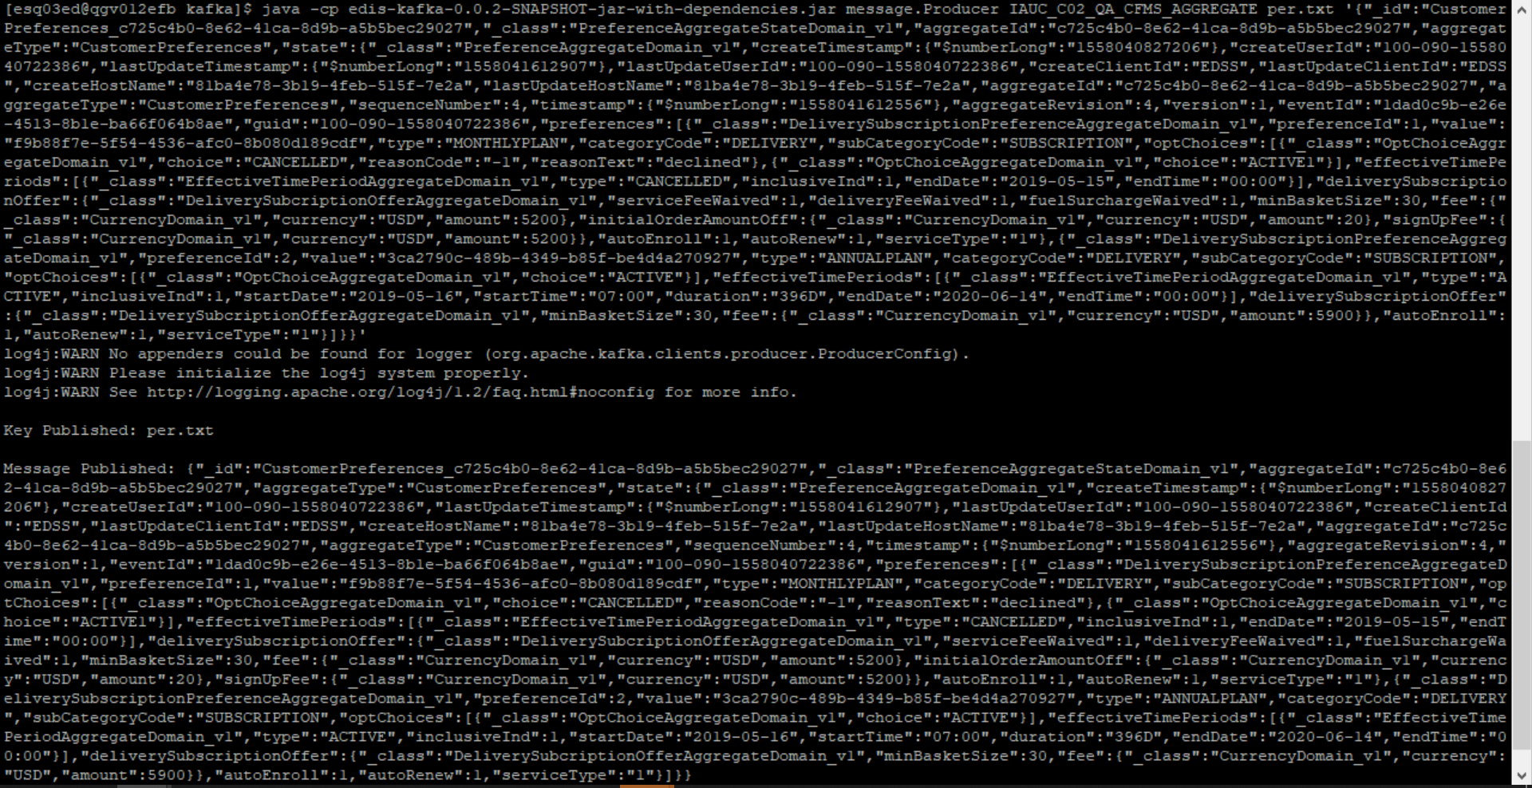



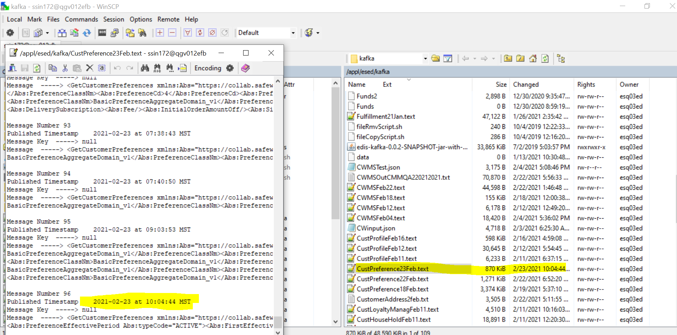

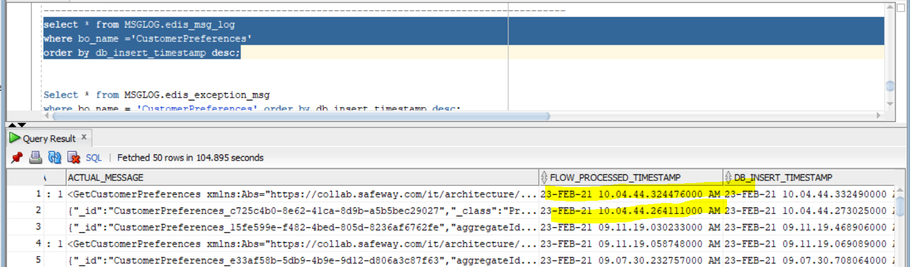

CMM xml –

<GetCustomerPreferences

xmlns:Abs="https://collab.safeway.com/it/architecture/info/default.aspx">

<DocumentData>

<Document VersionId="3.1.6.035" SystemEnvironmentCd="QA">

<Abs:DocumentID>IAUC_C02_QA_CFMS_AGGREGATE</Abs:DocumentID>

<Abs:AlternateDocumentID>IAUC_C02_QA_CFMS_AGGREGATE_1_1133_20210223100444266344</Abs:AlternateDocumentID>

<Abs:InboundOutboundInd>Outbound from Albertsons</Abs:InboundOutboundInd>

<Abs:DocumentNm>GetCustomerPreference</Abs:DocumentNm>

<Abs:CreationDt>2021-02-23T10:04:44.266344</Abs:CreationDt>

<Abs:Description>Retail customer&apos;s generic preferences and the subscriptions</Abs:Description>

<Abs:SourceApplicationCd>CFMS</Abs:SourceApplicationCd>

<Abs:TargetApplicationCd>EDIS</Abs:TargetApplicationCd>

<Abs:InternalFileTransferInd>Y</Abs:InternalFileTransferInd>

<Abs:DataClassification>

<Abs:DataClassificationLevel>

<Abs:Code>Internal</Abs:Code>

</Abs:DataClassificationLevel>

<Abs:BusinessSensitivityLevel>

<Abs:Code>Low</Abs:Code>

</Abs:BusinessSensitivityLevel>

<Abs:PHIdataInd>N</Abs:PHIdataInd>

<Abs:PCIdataInd>N</Abs:PCIdataInd>

<Abs:PIIdataInd>N</Abs:PIIdataInd>

</Abs:DataClassification>

</Document>

<DocumentAction>

<Abs:ActionTypeCd>UPDATE</Abs:ActionTypeCd>

<Abs:RecordTypeCd>CHANGE</Abs:RecordTypeCd>

</DocumentAction>

</DocumentData>

<CustomerPreferencesData>

<Abs:CustomerId>c725c4b0-8e62-41ca-8d9b-a5b5bec29027</Abs:CustomerId>

<Abs:CustomerPreferences>

<Abs:PreferenceClassNm>DeliverySubscriptionPreferenceAggregateDomain_v1</Abs:PreferenceClassNm>

<Abs:PreferenceCd>1</Abs:PreferenceCd>

<Abs:PreferenceTypeCd>MONTHLYPLAN</Abs:PreferenceTypeCd>

<Abs:PreferenceVal>f9b88f7e-5f54-4536-afc0-8b080d189cdf</Abs:PreferenceVal>

<Abs:PreferenceCategoryCd>DELIVERY</Abs:PreferenceCategoryCd>

<Abs:PreferenceSubCategoryCd>SUBSCRIPTION</Abs:PreferenceSubCategoryCd>

<Abs:OptChoice>

<Abs:ChoiceDsc>CANCELLED</Abs:ChoiceDsc>

<Abs:ReasonCd>-1</Abs:ReasonCd>

<Abs:ReasonDsc>declined</Abs:ReasonDsc>

</Abs:OptChoice>

<Abs:OptChoice>

<Abs:ChoiceDsc>ACTIVE1</Abs:ChoiceDsc>

</Abs:OptChoice>

<Abs:PreferenceEffectivePeriod Abs:typeCode="CANCELLED">

<Abs:LastEffectiveDt>2019-05-15</Abs:LastEffectiveDt>

<Abs:LastEffectiveTm>00:00:00.000</Abs:LastEffectiveTm>

<Abs:InclusiveInd>1</Abs:InclusiveInd>

</Abs:PreferenceEffectivePeriod>

<Abs:CustomerSubscriptions>

<Abs:SubscriptionId>f9b88f7e-5f54-4536-afc0-8b080d189cdf</Abs:SubscriptionId>

<Abs:SubscriptionCd>SUBSCRIPTION</Abs:SubscriptionCd>

<Abs:SubscriptionTypeCd>MONTHLYPLAN</Abs:SubscriptionTypeCd>

<Abs:DeliverySubscription>

<Abs:Fee CurrencyCd="USD" FeeAmt="5200.00"/>

<Abs:ServiceFeeWaivedInd>1</Abs:ServiceFeeWaivedInd>

<Abs:DeliveryFeeWaivedInd>1</Abs:DeliveryFeeWaivedInd>

<Abs:FuelSurchargeWaivedInd>1</Abs:FuelSurchargeWaivedInd>

<Abs:MinimumBasketSizeQty>30</Abs:MinimumBasketSizeQty>

<Abs:AutoRenewInd>1</Abs:AutoRenewInd>

<Abs:AutoEnrollInd>1</Abs:AutoEnrollInd>

<Abs:InitialOrderAmountOff CurrencyCd="USD" DiscountAmt="20.00"/>

<Abs:SignupFee CurrencyCd="USD" FeeAmt="5200.00"/>

</Abs:DeliverySubscription>

</Abs:CustomerSubscriptions>

</Abs:CustomerPreferences>

<Abs:CustomerPreferences>

<Abs:PreferenceClassNm>DeliverySubscriptionPreferenceAggregateDomain_v1</Abs:PreferenceClassNm>

<Abs:PreferenceCd>2</Abs:PreferenceCd>

<Abs:PreferenceTypeCd>ANNUALPLAN</Abs:PreferenceTypeCd>

<Abs:PreferenceVal>3ca2790c-489b-4349-b85f-be4d4a270927</Abs:PreferenceVal>

<Abs:PreferenceCategoryCd>DELIVERY</Abs:PreferenceCategoryCd>

<Abs:PreferenceSubCategoryCd>SUBSCRIPTION</Abs:PreferenceSubCategoryCd>

<Abs:OptChoice>

<Abs:ChoiceDsc>ACTIVE</Abs:ChoiceDsc>

</Abs:OptChoice>

<Abs:PreferenceEffectivePeriod Abs:typeCode="ACTIVE">

<Abs:FirstEffectiveDt>2019-05-16</Abs:FirstEffectiveDt>

<Abs:FirstEffectiveTm>07:00:00.000</Abs:FirstEffectiveTm>

<Abs:LastEffectiveDt>2020-06-14</Abs:LastEffectiveDt>

<Abs:LastEffectiveTm>00:00:00.000</Abs:LastEffectiveTm>

<Abs:DurationNbr>396</Abs:DurationNbr>

<Abs:DurationUnitDsc>Days</Abs:DurationUnitDsc>

<Abs:InclusiveInd>1</Abs:InclusiveInd>

</Abs:PreferenceEffectivePeriod>

<Abs:CustomerSubscriptions>

<Abs:SubscriptionId>3ca2790c-489b-4349-b85f-be4d4a270927</Abs:SubscriptionId>

<Abs:SubscriptionCd>SUBSCRIPTION</Abs:SubscriptionCd>

<Abs:SubscriptionTypeCd>ANNUALPLAN</Abs:SubscriptionTypeCd>

<Abs:DeliverySubscription>

<Abs:Fee CurrencyCd="USD" FeeAmt="5900.00"/>

<Abs:MinimumBasketSizeQty>30</Abs:MinimumBasketSizeQty>

<Abs:AutoRenewInd>1</Abs:AutoRenewInd>

<Abs:AutoEnrollInd>1</Abs:AutoEnrollInd>

<Abs:InitialOrderAmountOff/>

<Abs:SignupFee/>

</Abs:DeliverySubscription>

</Abs:CustomerSubscriptions>

</Abs:CustomerPreferences>

<Abs:SourceAuditData>

<Abs:SourceNm>CustomerPreferences</Abs:SourceNm>

<Abs:CreateTs>2019-05-16T21:07:07.206Z</Abs:CreateTs>

<Abs:LastUpdateTs>2019-05-16T21:20:12.907Z</Abs:LastUpdateTs>

<Abs:CreateClientId>EDSS</Abs:CreateClientId>

<Abs:CreateUserId>100-090-1558040722386</Abs:CreateUserId>

<Abs:LastUpdateClientId>EDSS</Abs:LastUpdateClientId>

<Abs:LastUpdateUserId>100-090-1558040722386</Abs:LastUpdateUserId>

<Abs:CreateHostNm>81ba4e78-3b19-4feb-515f-7e2a</Abs:CreateHostNm>

<Abs:LastUpdateHostNm>81ba4e78-3b19-4feb-515f-7e2a</Abs:LastUpdateHostNm>

<Abs:SequenceNbr>4</Abs:SequenceNbr>

<Abs:AggregateTs>2019-05-16T21:20:12.556Z</Abs:AggregateTs>

<Abs:AggregateRevisionNbr>4</Abs:AggregateRevisionNbr>

<Abs:PayloadVersionNbr>1</Abs:PayloadVersionNbr>

<Abs:EventId>1dad0c9b-e26e-4513-8b1e-ba66f064b8ae</Abs:EventId>

</Abs:SourceAuditData>

</CustomerPreferencesData>

</GetCustomerPreferences>